

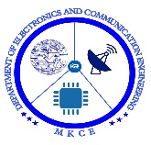

**DIAGNOSIS OF PARALYSIS BY USING IOT**

##### A MINOR PROJECT- I REPORT

###### ***Submitted by***

|  |  |
| --- | --- |
| DHARSHINI S | 927622BEC039 |
| GANASURUTHI B | 927622BEC051 |
| GIRIJA S | 927622BEC053 |
| HARINI S | 927622BEC051 |

##### 

**BACHELOR OF ENGINEERING**

in

**DEPARTMENT OF ELECTRONICS AND COMMUNICATION ENGINEERING**

**M.KUMARASAMY COLLEGE OF ENGINEERING**

(Autonomous)

**KARUR – 639 113**

**DECEMBER 2023**

**M.KUMARASAMY COLLEGE OF ENGINEERING, KARUR**

**BONAFIDE CERTIFICATE**

Certified that this **18ECP103-Minor Project I** report “**DIAGNOSIS OF PARALYSIS BY USING IOT”** is the bonafide work of “**DHARSHINI S, GANASURUTHI B, GIRIJA S, HARINI S”** who carried out the project work under my supervision in the academic year **2023-2024 - ODD**.

|  |  |
| --- | --- |
| **SIGNATURE**  **Dr.A.KAVITHA B.E., M.E., Ph.D.,**  **HEAD OF THE DEPARTMENT,**  Professor,  Department of Electronics and  Communication Engineering, Communication Engineering,  M.Kumarasamy College of Engineering, M.Kumarasamy College of Engineering, Thalavapalayam, Thalavapalayam,  Karur-639113. Karur-639113. | **SIGNATURE**  **Dr.A.MURUGAN** **B.E., M.E., Ph.D.,**  **SUPERVISOR,**  Professor,  Department of Electronics and Communication Engineering,  M.Kumarasamy College of Engineering, M.Kumarasamy College of Engineering, Thalavapalayam, Thalavapalayam,  Karur-639113. |

This report has been submitted for the **18ECP103L – Minor Project-I** final review held at M. Kumarasamy College of Engineering, Karur on **23-12-2023**

**PROJECT COORDINATOR**

**INSTITUTION VISION AND MISSION**

**Vision**

To emerge as a leader among the top institutions in the field of technical education.

**Mission**

**M1:** Produce smart technocrats with empirical knowledge who can surmount the global challenges.

**M2:** Create a diverse, fully -engaged, learner -centric campus environment to provide quality education to the students.

**M3:** Maintain mutually beneficial partnerships with our alumni, industry and professional associations

**DEPARTMENT VISION, MISSION, PEO, PO AND PSO**

**Vision**

To empower the Electronics and Communication Engineering students with emerging technologies, professionalism, innovative research and social responsibility.

**Mission**

**M1:** Attain the academic excellence through innovative teaching learning process, research areas & laboratories and Consultancy projects.

**M2:** Inculcate the students in problem solving and lifelong learning ability.

**M3:** Provide entrepreneurial skills and leadership qualities.

**M4:** Render the technical knowledge and skills of faculty members.

**Program Educational Objectives**

**PEO1:** **Core Competence:** Graduates will have a successful career in academia or industry associated with Electronics and Communication Engineering

**PEO2:** **Professionalism:** Graduates will provide feasible solutions for the challenging problems through comprehensive research and innovation in the allied areas of Electronics and Communication Engineering.

**PEO3:** **Lifelong Learning:** Graduates will contribute to the social needs through lifelong learning, practicing professional ethics and leadership quality

**Program Outcomes**

**PO 1: Engineering knowledge:** Apply the knowledge of mathematics, science, engineering fundamentals, and an engineering specialization to the solution of complex engineering problems.

**PO 2: Problem analysis:** Identify, formulate, review research literature, and analyze complex engineering problems reaching substantiated conclusions using first principles of mathematics, natural sciences, and engineering sciences.

**PO 3: Design/development of solutions:** Design solutions for complex engineering problems and design system components or processes that meet the specified needs with appropriate consideration for the public health and safety, and the cultural, societal, and environmental considerations.

**PO 4: Conduct investigations of complex problems:** Use research-based knowledge and research methods including design of experiments, analysis and interpretation of data, and synthesis of the information to provide valid conclusions.

**PO 5: Modern tool usage:** Create, select, and apply appropriate techniques, resources, and modern engineering and IT tools including prediction and modeling to complex engineering activities with an understanding of the limitations.

**PO 6: The engineer and society:** Apply reasoning informed by the contextual knowledge to assess societal, health, safety, legal and cultural issues and the consequent responsibilities relevant to the professional engineering practice.

**PO 7: Environment and sustainability:** Understand the impact of the professional engineering solutions in societal and environmental contexts, and demonstrate the knowledge of, and need for sustainable development.

**PO 8: Ethics:** Apply ethical principles and commit to professional ethics and responsibilities and norms of the engineering practice.

**PO 9: Individual and team work:** Function effectively as an individual, and as a member or leader in diverse teams, and in multidisciplinary settings.

**PO 10: Communication:** Communicate effectively on complex engineering activities with the engineering community and with society at large, such as, being able to comprehend and write effective reports and design documentation, make effective presentations, and give and receive clear instructions.

**PO 11: Project management and finance:** Demonstrate knowledge and understanding of the engineering and management principles and apply these to one’s own work, as a member and leader in a team, to manage projects and in multidisciplinary environments.

**PO 12: Life-long learning:** Recognize the need for, and have the preparation and ability to engage in independent and life-long learning in the broadest context of technological change.

**Program Specific Outcomes**

**PSO1:** Applying knowledge in various areas, like Electronics, Communications, Signal processing, VLSI, Embedded systems etc., in the design and implementation of Engineering application.

**PSO2:** Able to solve complex problems in Electronics and Communication Engineering with analytical and managerial skills either independently or in team using latest hardware and software tools to fulfil the industrial expectations.

|  |  |
| --- | --- |
| **Abstract** | **Matching with POs, PSOs** |
| **IoT, Arduino, paralysis, Diagnosis** | **PO1, PO2, PO3, PO6, PSO2** |

**ACKNOWLEDGEMENT**

Our sincere thanks to Thiru.M.Kumarasamy, Chairman and Dr.K.Ramakrishnan, Secretary of M.Kumarasamy College of Engineering for providing extraordinary infrastructure, which helped us to complete this project in time.

It is a great privilege for us to express our gratitude to Dr.B.S.Murugan., B.Tech., M.Tech., Ph.D., Principal for providing us right ambiance to carry out this project work.

We would like to thank Dr.A.Kavitha, Professor and Head, Department of Electronics and Communication Engineering for his unwavering moral support and constant encouragement towards the completion of this project work.

We offer our wholehearted thanks to our Project Supervisor, Dr.A.MURUGAN, Professor Department of Electronics and Communication Engineering for his precious guidance, tremendous supervision, kind cooperation, valuable suggestions, and support rendered in making our project successful.

We would like to thank our Minor Project Co-ordinator, Dr.K.Sivanandam, M.E., Ph.D., Associate Professor, Department of Electronics and Communication Engineering for his kind cooperation and culminating in the successful completion of this project work. We are glad to thank all the Faculty Members of the Department of Electronics and Communication Engineering for extending a warm helping hand and valuable suggestions throughout the project. Words are boundless to thank our Parents and Friends for their motivation to complete this project successfully.

**ABSTRACT**

We all know that the paralysis condition is a loss of muscle function in the body parts. It can affect any part of your body at any time, then probably you may won't feel the pain the affected area. Technical and Therapeutic innovations are there to improve the quality of life Our goal is to develop a device which should be easy to use and should be affordable which consists of basic health care monitoring system with nursing care. We know that these people can't able to convey their messages or needs. To overcome this, we come up with the system that helps these patients to display messages by very simple motion. This device can be designed to be mounted on the finger or to be inbuilt in their clothes.

**TABLE OF CONTENTS**

|  |  |  |  |  |
| --- | --- | --- | --- | --- |
| **CHAPTER No.** | **CONTENTS** | | | **PAGE No.** |
|  | **Institution Vision and Mission** | | | iii |
|  | **Department Vision and Mission** | | | iii |
|  | **Department PEOs, POs and PSOs** | | | iv |
|  | **Abstract** | | | viii |
|  | **List of Tables** | | | xi |
|  | **List of Figures** | | | xii |
|  | **List of Abbreviations** | | | xiii |
| **1** | **INTRODUCTION** | | | **1** |
|  | 1.1 | OBJECTIVE | | 2 |
|  |  |  | |  |
|  |  |  |  |  |
|  |  |  |  |  |
| **2** | **LITERATURE SURVEY** | | | **3** |
|  | 2.1 | Problem statement | | 3 |
|  |  |  | | .. |
| **3** | **EXISTING SYSTEM`** | | | **3** |
|  | 3.1 | Existing method | | 4 |
|  | 3.2 | Proposed system | | 4 |
| **4** | **PROJECT METHODOLOGY** | | | 5 |
| **5** | **COMPONENTS** | | | 6-10 |
|  | 5.1 Hardware component | | | 7 |
|  | 5.2 Software component | | | 9 |
|  |  | | |  |
| **6** | **CONCLUSION AND FUTUTE WORK** | | | 11 |
|  |  | | |  |
| **7** | **REFERENCES** | | | 12 |

**LIST OF TABLES**

|  |  |  |
| --- | --- | --- |
| **TABLE No.** | **TITLE** | **PAGE No.** |
| 5.1.1  5.1.2  5.1.3 | Arduino uno  Flux sensor  LCD display | 7  7  8 |
|  |  |  |
|  |  |  |
|  |  |  |

**LIST OF FIGURES**

|  |  |  |
| --- | --- | --- |
| **FIGURE No.** | **TITLE** | **PAGE No.** |
| **5.2** | Common Language Runtime | 10 |

**LIST OF ABBREVIATIONS**

|  |  |  |
| --- | --- | --- |
| **ACRONYM** |  | **ABBREVIATION** |

IoT - Internet Of Things

LCD - Liquid Crystal Display

CHAPTER 1  
INTRODUCTION

Patient Monitoring system is a process of continuously tracking the patient’s vital parameters. Usually, the patient monitoring is carried out by attaching the sensors. The components involved including the sensors network, Display Devices, Communication Wireless. Nodes and other supporting components Sensors are nothing but the Transducers which is used to capture all the physical quantities of the patient. Display devices are the devices which are used to accumulate the desired received signal and display in the appropriate content in the LCD or HMI displays. Communication devices, are usually shorter distance communication devices. Usually, the other supporting components involved in the patient monitoring system are the microcontroller units.

* 1. OBJECTIVE

In existing system of methodology, only there exists the technology of monitoring the patient heart rate in the nearby terminal display unit and the remote monitoring is enabled only when there exists the WIFI connectivity.

1. In this monitoring system, the implementation of the module is for the paralyzed patients.
2. This module comprises of parameters include food,water necessity from tha patient
3. The primary function of this system is to help the paralysis patient day to day life
4. To develop a gadget of wireless temperature and pressure sensors which will be as close as possible to the patient to mine requires patient data.
5. To develop physician terminal and attending healthcare giver terminals where patients data shall be processed to be sent to the Hospital data pool.
6. To build a database driven web portal were patients data shall be stored , analyzed

CHAPTER 2

2.1 LITERATURE SURVEY

Smart Healthcare is important for people who need nonstop monitoring which cannot be handed outside hospitals. It's also important at pastoral areas or townlets where near conventions can be in touch with megacity hospitals about their case’s health condition. This work presents a smart health monitoring system that uses biomedical detectors to check case’s condition and uses internet to inform the concerned. The biomedical detectors then are connected to Arduino UNO regulator to read the data which is in turn connived to an TV display/ diurnal examiner to see the affair. Body vitals ( Palpitation Temperature Moisture) are pivotal factors in determining wellbeing of case and help covering the strategy of treatment as well as record the response of treatment being conducted. While it can be excited and tedious to go for larger population of cases to collect the vitals information on a strict routine, the delicacy and the time pause as well as the estimation of instrumentation increases the threat of false cons.

2.2 PROBLEM STATEMENT

The smaller doctor to patient ratio indicates that there is a heavy burden on the doctors and healthcare providers in following up the healthy status of each individual patient admitted in Ward. Moreover, large distance between patient and physicians hinder the quality of health services as this in most cases is the matter of death and life

CHAPTER 3

SYSTEM ANALYSIS

3.1 EXISTING METHOD

In general, there are existing subsystems that can be wearable things such as bracelets, caps, t-shirts, bands, glasses Wearable processes can be tailored to the "real body." This equipment has been used to contact the person who is to be monitored, personal health and the information gathered which has been sent to the central and internal research centre. Most of these involve monitoring the patient's health by attending physician. Wearable devices may provide natural statistics, including calories, steps, heart rate, blood pressure; time spent exercising, and so on. The effect on these devices is enormous and of course very strong, which has a good focus on monitoring the physical health of our users.

3.2 PROPOSED METHOD

In the proposed system Paralysis is the inability to move muscles on your own and with purpose. It can be temporary or permanent. The most common causes are stroke, spinal cord injury, and multiple sclerosis. Paralysis can be a complete loss of movement known as a significant weakness called paresis. Paralysis is most often caused by damage in the nervous system, especially the spinal cord.

**CHAPTER 4**

**PROJECT METHODOLOGY**

The system uses hand motion recognition circuit, which is being transmitted using a transmitter circuitry. The reception of signal is done through a sophisticated receiver circuitry. The hand motion recognition circuit is used to sense hand movements with the help of accelerometer and gyroscope sensors.

**BLOCK DIAGRAM**

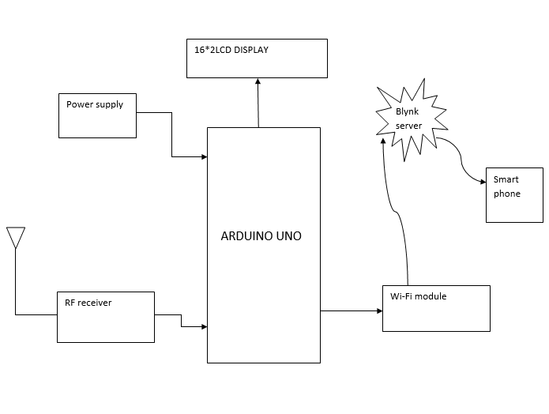

**CHAPTER 5**

**COMPONENTS REQUIRED**

**5.1 HARDWARE COMPONENTS**

* Arduino uno
* Flux sensor
* LCD display

**1.Arduino uno**

The **Arduino Uno** is an [open-source](https://en.wikipedia.org/wiki/Open-source) [microcontroller board](https://en.wikipedia.org/wiki/Single-board_microcontroller) based on the [Microchip](https://en.wikipedia.org/wiki/Microchip_Technology) [ATmega328P](https://en.wikipedia.org/wiki/ATmega328P) [microcontroller](https://en.wikipedia.org/wiki/Microcontroller) (MCU) and developed by [Arduino.cc](https://en.wikipedia.org/wiki/Arduino) and initially released in 2010. The [microcontroller board](https://en.wikipedia.org/wiki/Single-board_microcontroller) is equipped with sets of digital and analog [input/output](https://en.wikipedia.org/wiki/Input/output) (I/O) pins that may be interfaced to various [expansion boards](https://en.wikipedia.org/wiki/Expansion_board) (shields) and other circuits.[[1]](https://en.wikipedia.org/wiki/Arduino_Uno#cite_note-Makerspace-1) The board has 14 digital I/O pins (six capable of [PWM](https://en.wikipedia.org/wiki/Pulse-width_modulation) output), 6 analog I/O pins, and is programmable with the [Arduino IDE](https://en.wikipedia.org/wiki/Arduino#Software) (Integrated Development Environment), via a type B [USB cable](https://en.wikipedia.org/wiki/USB_cable). The word "[uno](https://en.wiktionary.org/wiki/uno)" means "one" in [Italian](https://en.wikipedia.org/wiki/Italian_language) and was chosen to mark a major redesign of the Arduino hardware and software.[[7]](https://en.wikipedia.org/wiki/Arduino_Uno#cite_note-7) The Uno board was the successor of the Due milanove release and was the 9th version in a series of USB-based Arduino boards

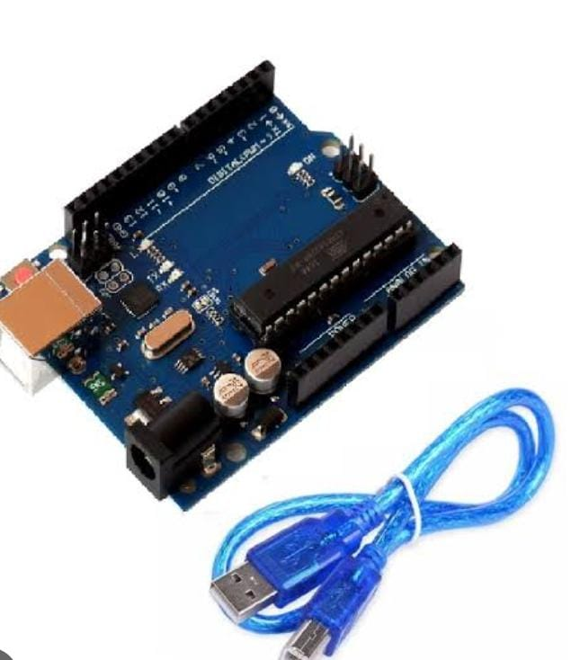

**2.Flux sensor**

A flux sensor is a low-cost, easy-to-use variable resistor that is designed to measure the amount of deflection it experiences when bent. The sensor's resistance is lowest when it's flat on the surface, increases when we bend it slowly and reaches its maximum when it's at a 90-degree angle.

Flex sensors are popular because they are used in many different applications like game controllers, data gloves, motion trackers, and even in biomedical devices to register static and dynamic postures. So in today's project, we will learn all about flex sensors, how it works, and how you can interface them with an Arduino.

**3.LCD DISPLAY**

LCD (Liquid Crystal Display) is a type of flat panel display which uses liquid crystals in its primary form of operation. LEDs have a large and varying set of use cases for consumers and businesses, as they can be commonly found in smartphones, televisions, computer monitors and instrument panels.

LCDs were a big leap in terms of the technology they replaced, which include light-emitting diode (LED) and gas-plasma displays. LCDs allowed displays to be much thinner than cathode ray tube ([CRT](https://www.techtarget.com/whatis/definition/cathode-ray-tube-CRT)) technology. LCDs consume much less power than LED

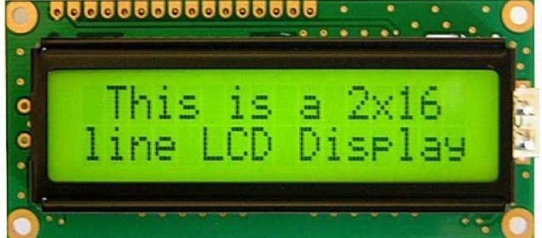

**5.2 SOFTWARE (PROGRAMMING)**

For this iot paralysis here we use C programming language as a input

#include "SoftwareSerial.h"

#include <EEPROM.h>

#include <Wire.h>

#include <LiquidCrystal_I2C.h>

LiquidCrystal_I2C lcd(0x27, 16, 2);

void printDetail(uint8_t type, int value);

int flux= A0;

unsigned int f;

SoftwareSerial mySoftwareSerial(9,10);

void setup()

{

Serial.begin(9600);

mySoftwareSerial.begin(9600);

Serial.println();

}

void loop()

{

f = analogRead(flux);

Serial.println(f);

lcd.setCursor(0, 1);

if (f <=86)

{

Serial.println("no help");

lcd.println("no help ");

delay(1000);

}

else if ((f>=87)&&(f<=87))

{

Serial.println("Please Give Me Food");

lcd.println("Give Me Food ");

delay(1000);

}

else if (f >=88)

{

Serial.println("Give Me Water");

lcd.println(("Give Me Water ");

delay(100);

}

else

//lcd.print("ON ");

{

if (f > 300)

//lcd.print("ON ");

delay(50);

}

lcd.begin();

lcd.setCursor(0, 0);

lcd.print("NEEDS");

}

**5.3 HARDWARE KIT**

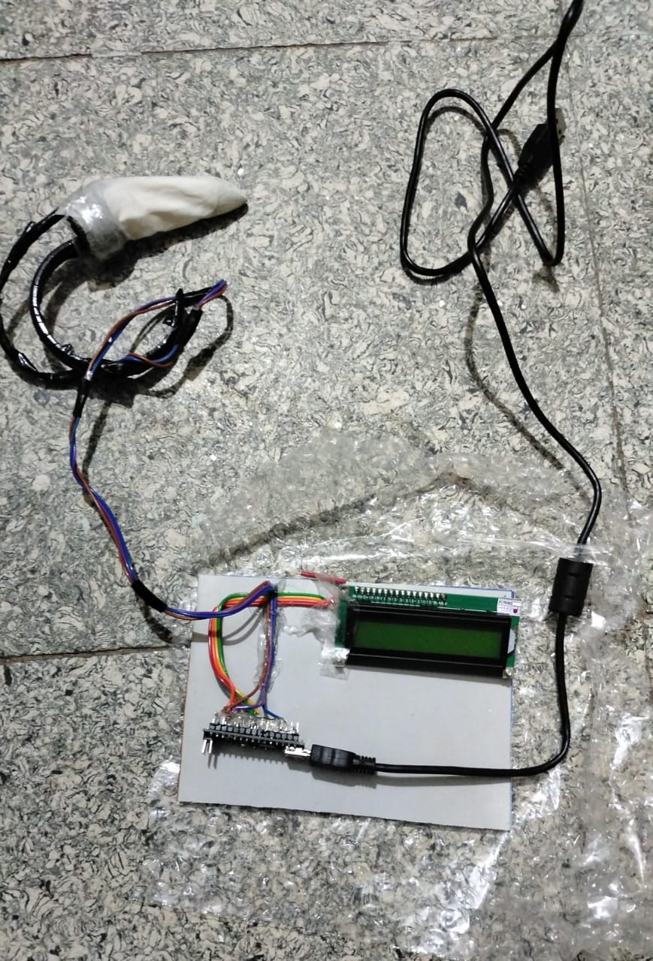

**CHAPTER 6**

**CONCLUSION**

Our system is all about taking care of a paralysis patient and for the safety of the patient. The patient can easily convey the message through just slight hand movement and his near ones can easily see if the patient stood up. When a patient is on bed and shows movement in any direction the message set for that direction will be displayed on screen as well as notification will be sent to the caretaker, family member's mobile phone and also would be able to see on the cloud. If the patient tries to stand up without any help, then also the message will convey, the patient had stood up so someone would go for help. And if the patient tries to stand up and at that time he tries to stand up and he falls on the ground then the emergency call will be made to the doctor and all of the others will get a message and application notification. This report provides information concerning the existence of the current system of patient monitoring and addresses the problems associated with that system. The recommendation of this proposed system is such that temperature and heart rate of patients while they are admitted in a ward should be using technology such as the internet of things and artificial intelligence to monitor all the patients under critical conditions. Therefore the effective use of this system would reduce the heavy burden of healthcare and consequently improve the quality of protecting lives through the use of technology to ensure humanity's prosperity and good life.

**FUTURE SCOPE**

In future, we can use the chipset to implement this system. All parts are integrated in the chip, so that we can. This chip fits easily with the patient with paralysis Gloves and bands avoid clothes.

**CHAPTER 7**

**REFERENCES**

1.AbhijeetBotre et al (2016) “Assistance system for paralyzed” published in International Journal of Innovative Research in Electrical, Electronics, Instrumentation and Control Engineering, Volume 4, Issue 5.

2. Gomez-Vilda et al (2016) “Vocal-fold paralysis patients treated with stem-cell grafting” published in International Conference on Pattern Recognition Systems (ICPRS-16).

3. Rolag Roy (2016) “Methodologies to assist patients” published in International Journal of Advanced Research in Electrical, Electronics and Instrumentation Engineering, Volume 5, Issue.

4. Hemakshi Pawar et al (2015) “Assistive Interactive Device using Electro - Oculography” published In International Journal of Advanced Research in Computer Engineering and Technology, Volume4, Issue 1.

5. Alyson Mathews de Carvalho Souza et al (2012) “Hand copter Game” published in Virtual and Augmented Reality (SVR).

6. Massage Coll et al (2012) “Treatment of Peripheral Facial Paralysis (PFP)” published in Photonics and Optoelectronics (SOPO)

7. Herta Floor et al (2000) “The Thought Translation Device (TTD) for Completely Paralyzed Patients” published in IEEE Transactions on Rehabilitation Engineering, Volume 8, No 2.